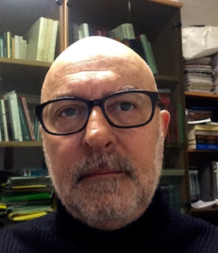
LUIGI GAUDINO
CURRENT ROLE
Associate professore

Personal informations
Place and date of birth: Trieste, april 15th 1958
Italian citizenship
: Udine, via Treppo 18
: luigi.gaudino@uniud.it
 +39 0432 249535

Work experience
From 2015 to present
UNIVERSITY OF UDINE
Teacher: Comparative legal systems and Comparative private law (scientific sector Ius 02)

From 2001 to present
UNIVERSITY OF UDINE
Teacher: Comparative private law (scientific sector Ius 02)

From 1989 to present
UNIVERSITY OF UDINE
Teacher: Private law (scientific sector Ius 01)

From 1983 to 1989
Commercial Technical Institutes in Trieste
Teacher: Technical and Business disciplines

Education and training
1989
University of Trieste
Degree in economics and business

1977
Classical High School F. Petrarca, Trieste
Secondary School Diploma in Classical Studies

Personal skills and competencies
Mother tongue | Italian
English | B2
French | B1

Other
Member of the ethics committee, Hospital of San Daniele del Friuli, Udine, Italy

Member of the SIRD (Italian association for comparative law research)

Publications
Author or co-author of over one hundred scientific publications in journals, treatises, commentaries, conference proceedings
Author of four academic books
Editor of one book
Author or co-author of several editions of private law exercises and diagrams books for students

Research
Research director in the field of personality rights and right to die with dignity

Scientific committees
Editorial board Responsabilità civile e previdenza, Giuffrè
Editorial board Multiverso, Udine, Forum editrice universitaria
Editorial board Responsabilità medica. Diritto e pratica clinica, Pacini editore

Conferences
Speaker at over 50 national and international congresses, conventions, seminars, conferences

I hereby authorize the processing of my personal data pursuant to art. 13 Legislative Decree 30 June 2003 No. 196 - "Personal data protection code" and art. 13 GDPR 679/16 – “European regulation on the protection of personal data

13/04/2023

